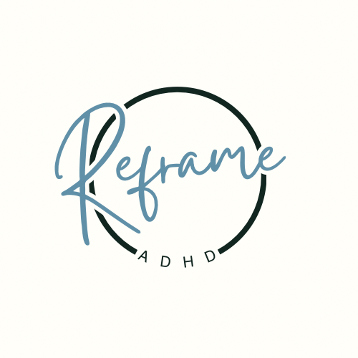

Accessibility Policy – ADHD Reframed

Effective Date: 1/1/2026
Website: www.adhdreframed.com
1. Statement of Commitment
ADHD Reframed is committed to providing an inclusive and accessible digital environment for all users.
We recognise our responsibilities under the Equality Act 2010 to make reasonable adjustments to ensure that disabled people are not placed at a substantial disadvantage when accessing our services.
We are committed to anticipating accessibility barriers wherever possible and removing or reducing them in a timely and proportionate manner.
2. Legal Framework
This policy reflects our obligations under:
• The Equality Act 2010
• The UK General Data Protection Regulation (UK GDPR) (where accessibility relates to user data access rights)
• The Web Content Accessibility Guidelines (WCAG) 2.1 Level AA
3. Accessibility Standards
We aim to conform, as far as reasonably practicable, with WCAG 2.1 Level AA standards.
These standards cover four key principles: content must be Perceivable, Operable, Understandable, and Robust.
In practical terms, we work to ensure:
• Text alternatives (alt text) for meaningful images
• Clear heading structures and logical page layout
• Sufficient colour contrast ratios
• Resizable text functionality (without loss of content)
• Keyboard navigability where technically possible
• Avoidance of content that flashes or may trigger seizures
• Plain English and structured content to support cognitive accessibility
• Compatibility with screen readers and assistive technologies
4. Reasonable Adjustments
Where a user experiences difficulty accessing our content, we will consider and implement reasonable adjustments where feasible.
This may include providing materials in alternative formats or offering additional support to access course content.
Requests for adjustments can be made via the contact details below.
5. Third-Party Platforms
Some functions (such as payment processing, hosting platforms, or embedded content) are delivered via third-party providers.
While we select providers that prioritise accessibility, we cannot guarantee full compliance for external platforms.
However, we will raise accessibility concerns with providers where appropriate.
6. Ongoing Review and Monitoring
Accessibility is an ongoing process. ADHD Reframed will:
• Periodically review website accessibility
• Respond promptly to accessibility feedback
• Update content to reflect current WCAG guidance where appropriate
• Implement improvements within reasonable technical and financial constraints
7. Feedback and Contact
We welcome feedback on the accessibility of ADHD Reframed’s services.
If you encounter accessibility barriers, please contact:
Email: [Insert Contact Email]
We aim to acknowledge accessibility requests within 5 working days and provide a substantive response within 10 working days.
8. Escalation
If you are not satisfied with our response, you may seek further advice from:
Equality Advisory and Support Service (EASS)
Information Commissioner’s Office (ICO) – where relevant to data accessibility
9. Policy Updates
This Accessibility Policy will be reviewed periodically and updated where necessary to reflect changes in legal standards or improvements in accessibility practices.

